**Activate Windows Server**

**Step 1**

> Run as administrator “CMD”

> Enter [cd windows\system32]

> Running [cscript.exe slmgr.vbs –skms 172.16.2.1]

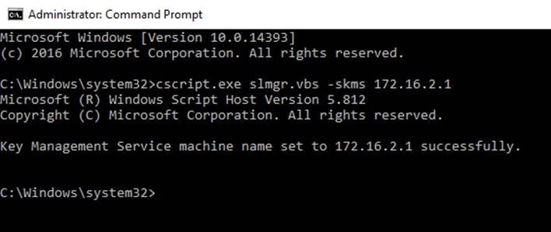

**Step 2**

> Running [cscript.exe slmgr.vbs –ato]

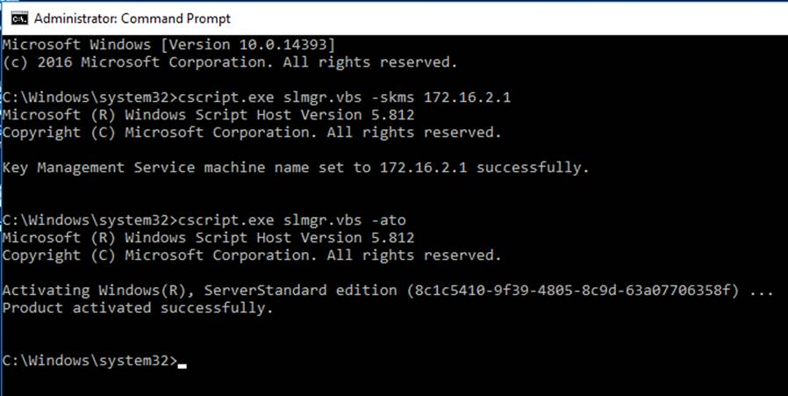

Remark: Please Activated every 6 months